**Gas Leakage Monitoring and Alerting System for Industries**

|  |  |
| --- | --- |
| **PROJECT NAME** | GAS LEAKAGE MONITORING & ALERTING SYSTEM FOR INDUSTRIES |
| **TEAM ID** | PNT2022TMID25975 |
| **TEAM MEMBERS** | 1. DASA SARANYA  2. KRISTAVARAPU RAMYA SRI  3. VANGALA SOWMYA  4. RAGHAVI.B |
| **BRANCH** | ELECTRONICS AND COMMUNICATION ENGINEERING |

**Abstract:**

Liquefied Petroleum Gas (LPG) is a main source of fuel, especially in urban areas because it is clean compared to firewood and charcoal. Gas leakage is a major problem in the industrial sector, residential premises, etc. Nowadays, home security has become a major issue because of increasing gas leakage. Gas leakage is a source of great anxiety with ateliers, residential areas and vehicles like Compressed Natural Gas (CNG), buses, and cars which are run on gas power. The different types of gas sensors technologies including catalytic gas sensor, electrochemical gas sensors, thermal conductivity gas sensor, optical gas sensor and acoustic gas sensor are discussed together with their principle of operation. This proposed system also includes an alerting system for the users. The system is based on a sensor that easily detects a gas leakage. The proposed IOT to be installed through a manual approach or virtual approach is depending on the consumer interest. There were many instances experiencing the many people to become victims of this and also the environment to be also spoiled and it takes more time to purify the infected environment or to bring the affected environment to a normal level.

**Introduction:**

Gas leakage is a serious problem and nowadays it is observed in many places like residences, industries, and vehicles like Compressed Natural Gas (CNG), buses, cars, etc. It is noticed that due to gas leakage, dangerous accidents occur. In our daily lives, we are encountering many situations such as gas cylinder burns with negligence of the user in the kitchen, also many gas industries pipeline to be leaked and emitting toxic gas that harms the people living in the society, and many other situations depicting the consequences when the gas to be leaked outside. Liquid petroleum gas (LPG) is highly inflammable and can burn even at some distance from the source of leakage. This energy source is primarily composed of propane and butane which are highly flammable chemical compounds. These gases can catch fire easily. The reason for such explosions is due to substandard cylinders, old valves, no regular checking of gas cylinders, worn out regulators and a lack of awareness of handling gas cylinders. Therefore, the gas leakage should be detected and controlled to protect people from danger. Gas sensors are chemical sensors that are of paramount importance. A chemical sensor comprises of a transducer and an active layer for converting the chemical information into another form of electronic signal like frequency change, current change or voltage change.

**Objective:**

The main objective of the proposed Gas Leakage Detection and Automatic Control System (GLDACS) is to provide a solution by designing an automatic system which can detect the leakage of liquefied petroleum gas (LPG) at home and control it by turning off the cylinder knob. A gas leakage detector becomes vital and helps to protect people from the dangers of gas leakage. A number of research papers have been published on gas leakage detection techniques

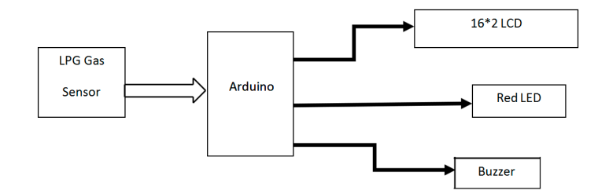

**Problem Formulation:**

A mixture of propane and butane makes up the highly flammable liquid petroleum gas (LPG) chemical. LPG is used for cooking in restaurants, at home, and in industrial applications. They have a few flaws, which cause the gas to leak. Gas leaks can only be discovered by adjacent humans; if no one is around, they cannot be found. But occasionally a human with a poor sense of smell cannot notice it. As a result, this device will aid in detecting gas leaks.

Gas leaks can potentially start fires that harm human property and inflict catastrophic injuries or fatalities. IOT was used in the development of this system to provide users with real-time feedback and send notifications to users.

**List of Components :-**

|  |  |  |
| --- | --- | --- |
| **S. No** | **Name of the Component** | **Quantity** |
| 1. | Arduino UNO R3 | 1 |
| 2. | Breadboard | 1 |
| 3. | LED | 2 |
| 4. | Resistor | 5 |
| 5. | Piezo | 1 |
| 6. | Gas Sensor | 1 |
| 7. | LCD 16*2 | 1 |
| 8. | Potentiometer | 1 |

The required [basic electronics components](https://www.elprocus.com/basic-components-used-electronics-electrical/" \t "https://www.elprocus.com/microcontroller-based-lpg-leakage-detector-circuit-and-working/_blank) for designing a microcontroller based LPG leakage detector circuit mainly include Arduino Pro Mini, LPG gas sensor module, buzzer, BC 547 transistor, 16×2 LCD, 1K resistor, bread board, 9 volt battery and connecting wires.

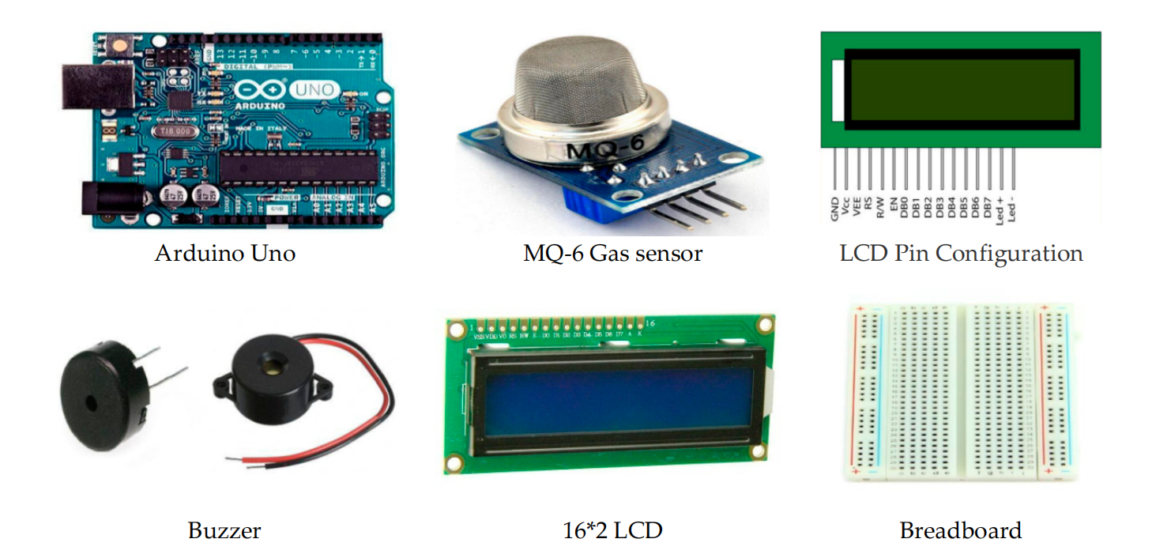

Gas Sensors:

Electronic devices called gas sensors (sometimes referred to as gas detectors) are used to locate and classify various gases. They are frequently employed to gauge gas concentrations and identify explosive or dangerous gases. Gas sensors are used in manufacturing facilities and factories to find gas leaks and to detect smoke and carbon monoxide in residential buildings. Gas sensors come in a wide range of sizes (portable and fixed), sensing capabilities, and ranges. They frequently function as a component of a larger embedded system, such as security and hazmat systems, and are typically connected to an interface or audible alarm. Gas sensors require more frequent calibration than many other types of sensors since they are continually reacting with air and other gases.

Arduino Uno:

A microcontroller board called Arduino UNO is based on the ATmega328P. It contains 6 analogue inputs, a 16 MHz ceramic resonator, 14 digital input/output pins (six of which can be used as PWM outputs), a USB port, a power jack, an ICSP header, and a reset button. It comes with everything needed to support the microcontroller; to get started, just plug in a USB cable, an AC-to-DC adapter, or a battery. You can experiment with your UNO without being overly concerned that you'll make a mistake; in the worst case, you can replace the chip for a few dollars and start over.

LCD:

Liquid crystal display is referred to as LCD. It is a particular type of electronic display module used in a wide array of circuits and devices, including mobile phones, calculators, computers, TVs, and other electronics. These displays are mostly preferred for seven segments and multi-segment light-emitting diodes. The main advantages of adopting this module are its low cost, ease of programming, animations, and unlimited ability to display bespoke characters, unique animations, etc. The LCD device's inexpensive cost and low power consumption are two of its key benefits. So these LCDs run on AC power that has a frequency of less than 500 Hz.

BUZZER:

A beeper or buzzer, for example, could be electromechanical, piezoelectric, or mechanical in design. The signal is converted from audio to sound as its primary function. It is often powered by DC voltage and used in timers, alarm clocks, printers, computers, and other electronic devices. It can produce a variety of sounds, including alarm, music, bell, and siren, according on the varied designs.

**Proposed Method :-**

In this study, LPG gas is detected using semiconductor sensors. It makes use of a semiconductor sensor. The gas sensor's sensitive component is SnO2, which has a reduced conductivity in clean air. The sensor conductivity rises along with the rising gas concentration when the target flammable gas is present. The gas sensor responds to natural gas and has great sensitivity to propane, butane, and LPG. The sensor has a low cost and can be utilised for a variety of applications. It can be used to detect many flammable gases, including Methane. Anywhere between 200 and 10,000 ppm of gas concentration can be detected by the sensor. The output of the sensor is an analogue resistance. The gas leak detection and alert system's block diagram.

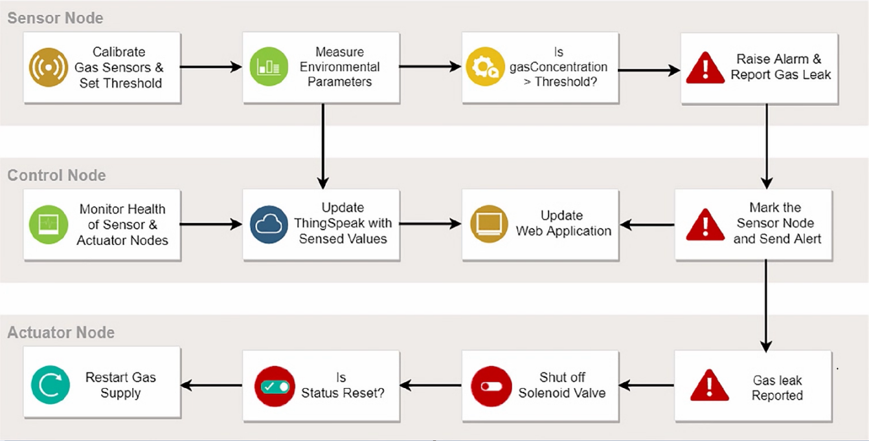

The sensor output will be used as digital input by Arduino. The buzzer will start to tune and the LCD will display "Gas detected: Yes" if the sensor output is high. The bell won't tune and the LCD will display "Gas detected: No" if the sensor output is low. The buzzer typically consists of a number of switches or sensors that are connected to a control unit that can identify which button was pressed or whether a predetermined amount of time has passed. The buzzer also typically illuminates a light on the appreciate button or control panel and emits a warning sound in the form of a continuous or sporadic buzzing or beeping sound.

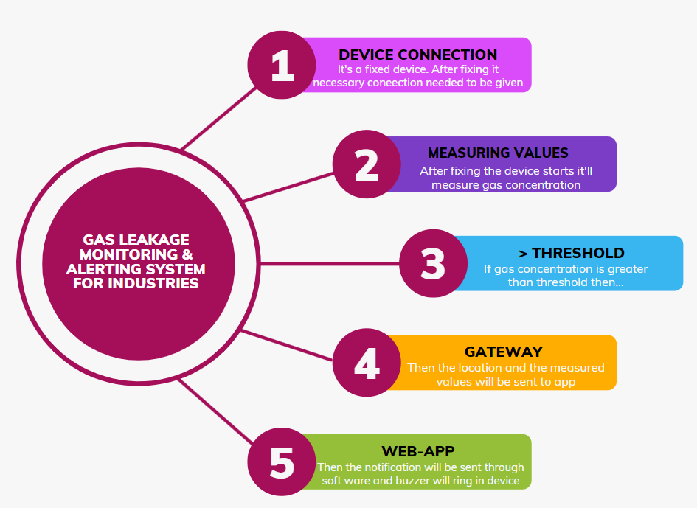

**Circuit Diagram :-**

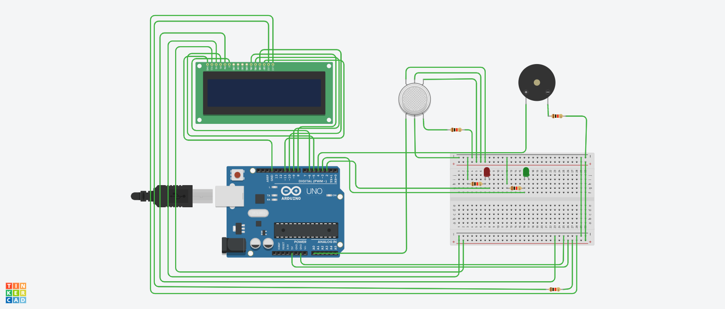

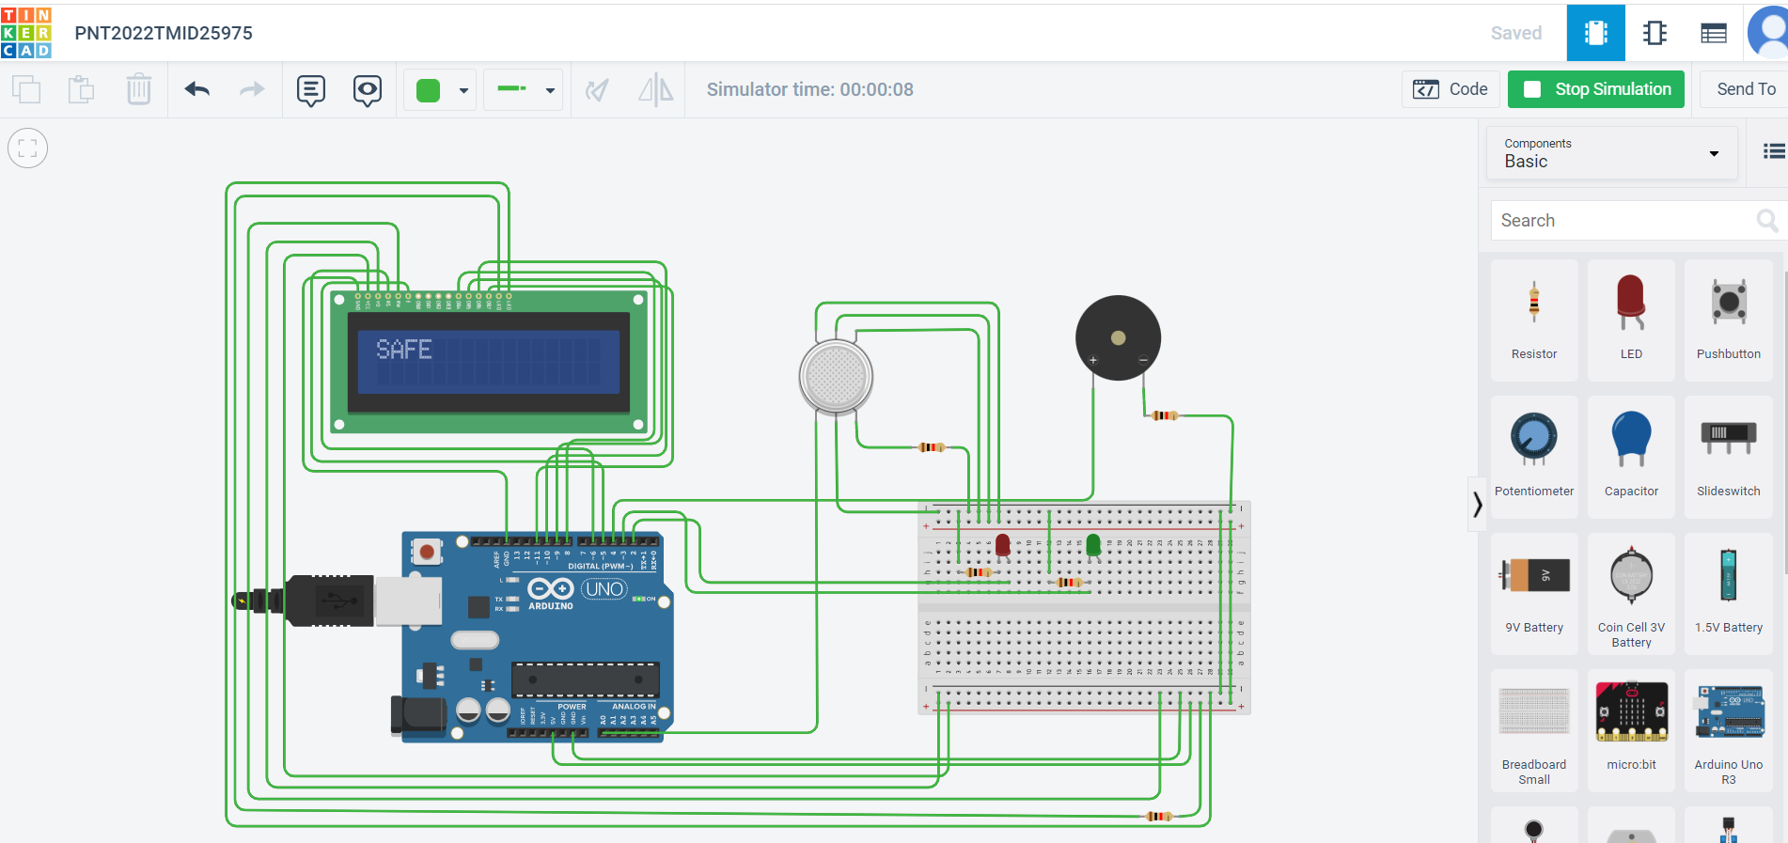

**Solution Statement :-**

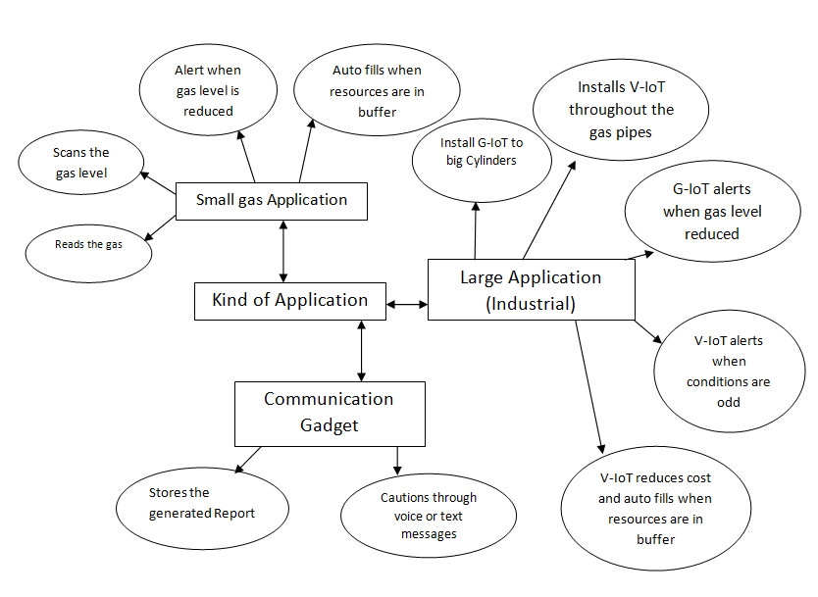

The alarm, which includes a buzzer, will sound if the system detects a gas concentration in the air that is higher than the safety limit, alerting the users at home to the anomalous situation and enabling them to take any necessary action. The smell of gas in the house is the most obvious indicator of a leak. However, there are specific bodily symptoms that you might experience if there is a carbon monoxide leak. The output of this study is that the leakage will be found and terminated two seconds after it begins. The degree of gas leakage can even be detected by this technology. This is a powerful technique for automatically locating and stopping the gas leak.

Moreover, the fire incidents are also averted by cutting off the power supply. The concept of gas detection and control can be applied broadly across a range of industries. This system can be put in any room, including a restaurant in a hostel. This may help to lessen mishaps brought on by gas leakage in residential areas in addition to in comparable commercial settings. There are 180 million people living in our nation, and our product is affordable, will avoid many mishaps, and will protect countless homes, businesses, and lives.

**Conclusion:**

We can infer from the project's performance that the system's detection of LPG gas leakage is remarkable. Useful for both residential and commercial purposes. We can use this technique to save lives in dangerous situations. The GSM module indicates an alert. Propane, CO2, and other gases are detected by a sensor node. Power usage and transmission range are estimated. The sensor was constructed using simple techniques and an Arduino UNO Micro controller.

**References:**

* <https://www.academia.edu/81270911/IoT_Based_LPG_Gas_Level_Detection_and_Gas_Leakage_Accident_Prevention_with_Alert_System?f_ri=241365>
* <https://www.semanticscholar.org/paper/Gas-leakage-detection-and-alerting-system-using-Uno-Shahewaz-Prasad/176f9c7c278524425b7c9ff9491ee1f2a0095b4b>
* <https://jeeeccs.net/index.php/journal/article/view/172>
* <https://www.pramanaresearch.org/gallery/22.%20feb%20ijirs%20-%20d539.pdf>
* <https://www.researchgate.net/figure/Comparison-of-gas-detection-sensor-technologies_tbl2_285988329>